Lab 2: Containerization & Kubernetes Orchestration
Task 5: Manage Docker containers and images

1. Objective
List, start, stop and remove containers, tag and push an image to a registry, and use Docker Compose for a multi-container setup.

2. Container management
docker ps
docker stop lab2-app
docker ps -a
docker start lab2-app
docker exec lab2-app ls /app
docker rm lab2-app
docker images lab2-python-app

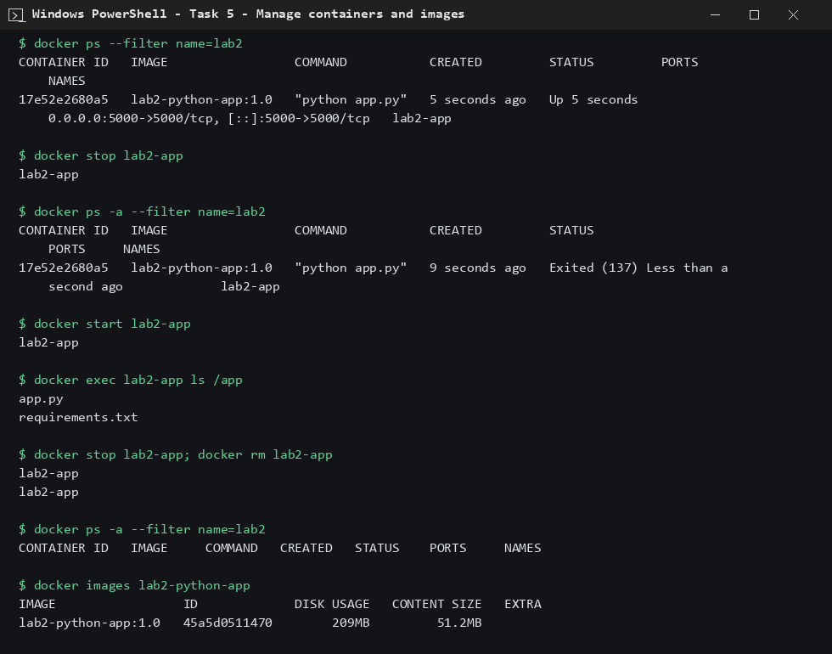
Figure 1: Listing, stopping, starting and removing a container

3. Tag and push to a registry
A local registry container (registry:2) was started and the image was tagged and pushed to it.
docker run -d -p 5050:5000 --name lab2-registry registry:2
docker tag lab2-python-app:1.0 localhost:5050/lab2-python-app:1.0
docker push localhost:5050/lab2-python-app:1.0
curl localhost:5050/v2/_catalog

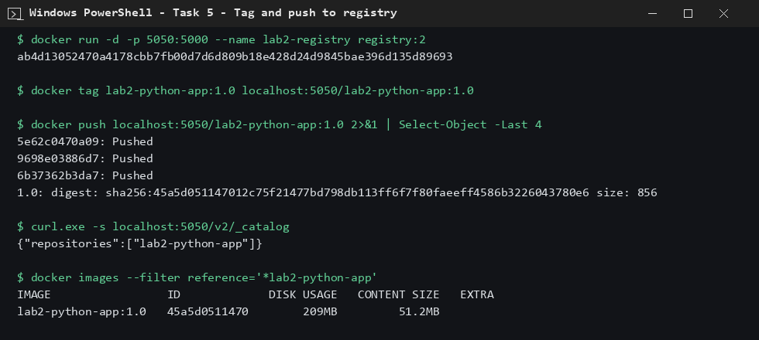
Figure 2: Image tagged and pushed; registry catalog lists it

4. Docker Compose
A web service (Flask) and a redis service were started together with one command. The visit counter is stored in redis.
services:
web:
build: ./web
image: lab2-compose-web:1.0
container_name: lab2-compose-web
ports:
- "5001:5000"
environment:
- REDIS_HOST=redis
depends_on:
- redis

redis:
image: redis:7-alpine
container_name: lab2-compose-redis
expose:
- "6379"

docker compose up -d --build
docker compose ps
docker compose down

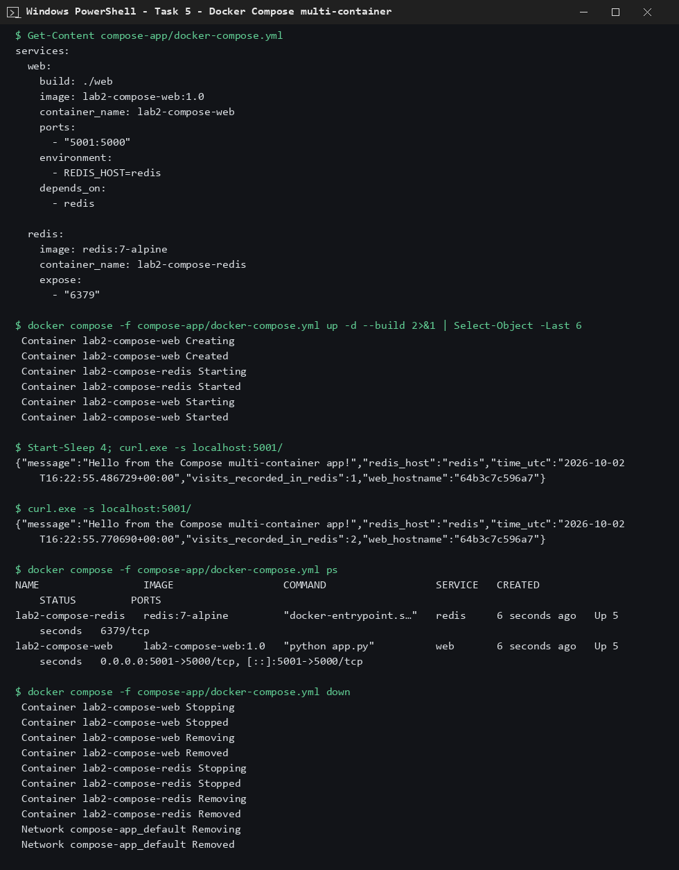
Figure 3: Compose app running (visit counter 1 -> 2) and torn down

5. Conclusion
Container lifecycle commands, tagging/pushing to a registry and a two-service Compose application all worked as expected.

